How to Renew Your Optometry License
- Go to www.kssbeo.ks.gov , click on the link: RENEW YOUR LICENSE HERE
- Enter License number; last 4 digits of SSN, Date of Birth, and select Renew Your License from the drop downs in the Action Box
- On the Personal page, verify that home address, email address, and phone numbers are correct
- Click Save and Continue at Bottom of page
- On the Practice page. Verify that the information listed is correct. Click the Edit button to be sure that all licensees that are practicing at your location are listed. If you need license numbers please contact the Board office at 785-832-9986
- Be sure to click the box at the bottom of the page that you have verified the information on page.
- Click Save and Continue at the Bottom of the page
- On the License page, be sure to select License Status (Active or Inactive) and all states that you are currently licensed in are selected.
- On the Insurance page, enter insurance information and expiration date. Be sure to check the box that you have verified information:
- On the Education page, if you have CE has not been reported to the OEtracker and listed, you will need to add the hours at the very bottom of the page: 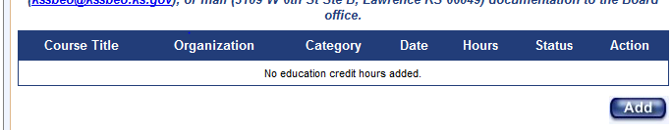
- Any hours that are added here, will need to be faxed (785-856-2323), emailed (kssbeo@kssbeo.ks.gov) or mailed directly to the Board office. You do not need to submit any hours to the Board office if they are already showing in the OETracker.
- Be sure to enter the total number of internet hours (non-live) into the box at the bottom. Note: this box will only accept the maximum of 16 hours for two years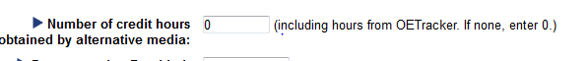
- Click Save and Continue at the bottom of the page.
- On the Disclosure page, give any information as required. Fax/email/mail any supporting documentation as needed.
- Click Save and Continue at the bottom of the page.
- On the Summary page if you have the Continue button, you can finish your renewal online by entering your payment information. Hopefully your Application Progess looks like this: 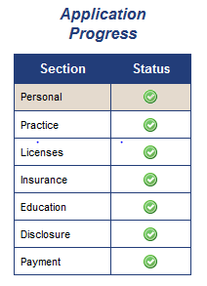
- If you have any Red check marks go back to that section. It could be as simple as not checking a box. You can still have a red check mark under Education and be allowed to continue if you have added hours and the office has not verified those hours yet. As long as you have the Continue button on the Summary page, you will be able to complete your renewal in Pending Status. As soon as the Board office gets everything that is required, your application will be complete and the renewal certificate mailed out.
- If you still cannot complete your renewal, please contact the Board office at 785-832-9986.

