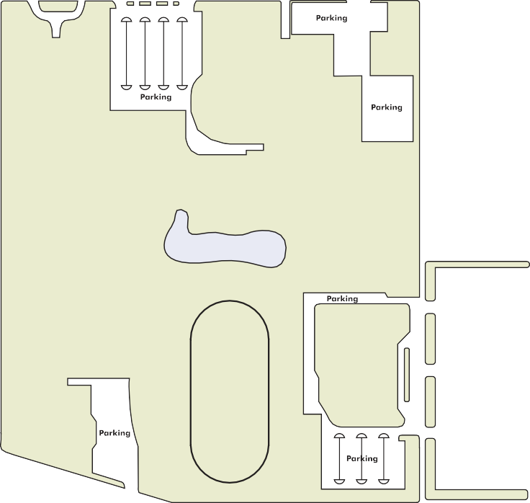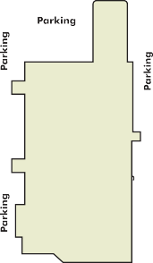

- Parker Student Union (PSU)
- Lockman Hall (LH)
- Student Health
- Rimmer Learning Resource Center (RLC)
- Smith Science Center (SH)
PARKING
- Cosmosphere
- Shears Technology Center (STC)
- Ade-Wifco/RCIC (AW)
- Office Technologies - (OT)
- Tennis Courts
- Gowans Stadium
- Jack Mull Family Football Complex
and I-135
- Stringer Fine Arts Center (FA)
- Sports Arena
- Kent Hall
- Elland Hall
- Child Care Center
- Hutchinson Career & Technical Education Academy
- Dragon’s Landing
- Berger Industrial Technology Center (ITC)
- Motorcycle Storage & Maintenance

K-96 from Lyons
56th St.
K-61 from McPherson N
30th St.
4

17th St.
3
Municipal Airport
2
8th St.
11th St.

HUTCH
“G” Ave.
8
4th St. 7
Monroe St.
Main St. Walnut St. Polplar St.
Plum St.
Lorraine
Airport Rd.
50

US-50 from Newton
US-50 from Dodge City
50
K-61 from Pratt
Yoder Rd. - 6 mi.

5
Yoder, KS

Ranger Rd.
HUTCHINSON COMMUNITY COLLEGE

1300 N. Plum • Hutchinson, KS 67501
HutchCC Main Campus
(Student Union) (14th & Plum)
2 Davis Hall (9th & Walnut)
Peel Center (9th & Main)
3 Sports Arena (700 E 11th)
4 Building 12 (1800 N. Plum)
5 Wagner Building (1800 E Essex Rd)
6 Pioneer Building (1809 E Essex Rd)
7 Fire Science Center (3211 E 4th)
8 Cosmetology (200 E 3rd)
Yoder at K-96 (Wichita)
6
South Campus
Wasp Rd.
Greenfield Rd.
Halstead Rd.
1-888-GO HUTCH • WWW.HUTCHCC.EDU

